**Peer-graded Assignment: Project Submission**

**Console-Based Inventory Management System in C#**

**Step 1: Review the design challenges**

1. To complete this challenge, you will need to create a console application where users can manage product stock. Users should be able to add new products, update stock, and remove products.
2. Some key features include:
   1. Add new products with name, price, and stock quantity;
   2. Update stock when products are sold or restocked;
   3. View all products and their stock levels;
   4. Remove products from inventory;

**Step 2: Define the project requirements and objectives**

Intro: you now know the issue that you’re trying to solve. Take some time to determine the project requirements and objectives. Remember, requirements fall into two categories: functional and non-functional. Then, set the project objectives- the specific results you aim to achieve.  You’ll submit these requirements and objectives at the end of this project.

**Project Overview**

This project is a console-based Inventory Management System. The program will allow users to manage product stock by adding, updating, viewing, and removing products. The system will store product data in memory during runtime and provide a user-friendly menu for interaction.

**Functional Requirements (what the system should do)**

1. The system must allow users to add new products with the following details:

* Name (string);
* Price (decimal);
* Stock quantity (integer).

1. The system must allow users to view all products, displaying their name, price, and current stock;
2. The system must allow users to update stock levels when items are sold or restocked (positive or negative adjustment);
3. The system must allow users to remove a product from inventory by name;
4. The system must present a menu of options in a loop until the user chooses to exit.

**Non-Functional Requirements (how the system should behave)**

1. The system must be a console application written in C#;
2. The program should handle user input errors gracefully (e.g., invalid menu option or wrong data type);
3. Code should be modular, using separate methods for each major function (e.g., AddProduct, UpdateStock);
4. The system should be easy to use, with clear instructions and labels.

**Project Objectives**

1. Design and implement a working inventory system using object-oriented principles;
2. Demonstrate control structures (e.g., if-else, switch) for decision-making logic;
3. Use loop constructs (while, for) to support ongoing interaction;
4. Apply function decomposition by defining and calling custom methods;
5. Practice structured programming and basic user interaction in a C# console environment.

**Step 3: Create a design outline**

1. **Major Tasks and Code Planning:**

|  |  |  |
| --- | --- | --- |
| **Task** | **Description** | **Code component needed** |
| Display menu | Show user options (Add, View, Update, Remove, Exit) | Switch or if-else loop |
| Add new product | Get input: name, price, stock. Create and store product. | Method: AddProduct() variables |
| View inventory | Display all products in list | Method: ViewInventory() foreach |
| Update product stock | Search product by name adjust stock (add or subtract) | Method: UpdateStock() conditionals |
| Remove product | Search product by name, remove from list | Method: RemoveProduct(), list methods |
| Keep program running | Loop through menu until exit is chosen | While or do-while loop |
| Handle errors | Validate user input, display error messages | Try-catch, if-else |

1. **Planned Variables:**

|  |  |  |
| --- | --- | --- |
| **Variable Name** | **Type** | **Purpose** |
| inventory | List<Product> | Stores all products in memory |
| name | string | Holds product name input |
| price | decimal | Holds product price input |
| stock | int | Holds quantity input |
| choice | string | Hold user menu selection |

1. **Planned Methods:**

* AddProduct(): get product input and adds to inventory;
* ViewInventory(): display all products;
* UpdateStock(): modifies stock of selected product;
* RemoveProduct(): deletes product by name.

1. **Control Structures:**

* Switch-case: for handling user menu choices;
* If-else: for conditions (e.g., product found or not);
* While loop: keeps menu running until user exits

1. **Flowchart/Diagram Suggestion**

The flowchart in Picture 1 illustrates the core logic of the Inventory Management System console application. It begins with the program displaying a menu of options, allowing the user to choose between adding a new product, viewing the current inventory, updating stock quantities, or removing a product. Each option leads to a specific set of actions, such as collecting user input, modifying the product list, or displaying product details. After completing the selected task, the system prompts the user to decide whether to continue using the application or exit. This loop ensures continuous interaction until the user explicitly chooses to terminate the program, providing a structured and user-driven experience.

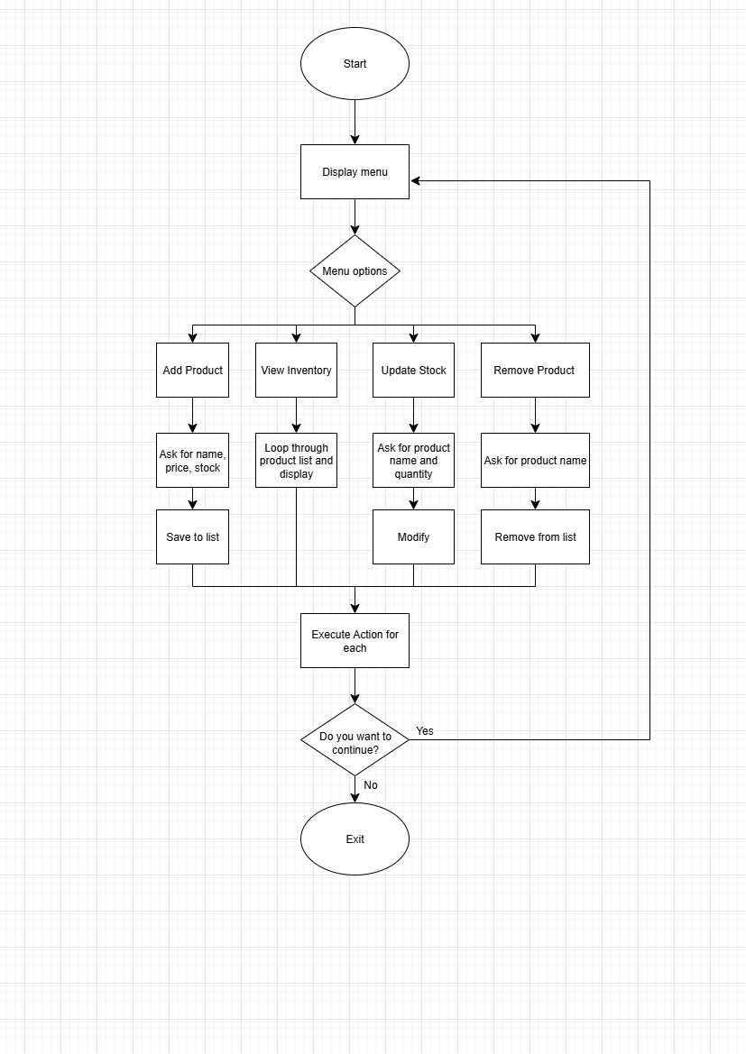

**Picture 1 – Inventory Management System Flowchart**

**Step 4: Build the application**

Intro: with your plan in place, you can begin creating the application using C# in Visual Studio Code. This is the first time you’ve written code entirely independently, so take your time and review earlier lessons for a refresher. Also, feel free to leverage Copilot to help you code. Copilot can help you write, analyze, debug, and optimize your code as you’re going. Remember that all generative AI tools are meant to work in conjunction with you and require your input and knowledge to complete tasks.

To show your understanding of the concepts in this course, make sure your code includes:

* Control structures like if-else and switch statements;
* Loops like for and while;
* Methods that you define and call.

**Code:**

**class** **Product**(**string** name, **decimal** price, **int** stock)

{

**public** **string** Name { **get**; **set**; } = name;

**public** **decimal** Price { **get**; **set**; } = price;

**public** **int** Stock { **get**; **set**; } = stock;

**public** **void** **Display**()

{

Console.WriteLine($"Name: {Name}, Price: ${Price}, Stock: {Stock}");

}

}

**class** **Program**

{

**static** **readonly** List<Product> inventory = [];

**static** **void** **Main**()

{

**bool** running = **true**;

**while** (running)

{

Console.WriteLine("\nInventory Management System");

Console.WriteLine("1. Add Product");

Console.WriteLine("2. View Inventory");

Console.WriteLine("3. Update Stock");

Console.WriteLine("4. Remove Product");

Console.WriteLine("5. Exit");

Console.Write("Choose an option (1-5): ");

**string** choice = Console.ReadLine() ?? **string**.Empty;

**switch** (choice)

{

**case** "1":

AddProduct();

**break**;

**case** "2":

ViewInventory();

**break**;

**case** "3":

UpdateStock();

**break**;

**case** "4":

RemoveProduct();

**break**;

**case** "5":

running = **false**;

**break**;

**default**:

Console.WriteLine("Invalid option. Please choose between 1 and 5.");

**break**;

}

}

Console.WriteLine("Exiting the program. Goodbye!");

}

**static** **void** **AddProduct**()

{

Console.Write("Enter product name: ");

**string** name = Console.ReadLine() ?? **string**.Empty;

Console.Write("Enter price: ");

**if** (!**decimal**.TryParse(Console.ReadLine(), **out** **decimal** price))

{

Console.WriteLine("Invalid price input.");

**return**;

}

Console.Write("Enter stock quantity: ");

**if** (!**int**.TryParse(Console.ReadLine(), **out** **int** stock))

{

Console.WriteLine("Invalid stock input.");

**return**;

}

inventory.Add(**new** Product(name, price, stock));

Console.WriteLine("Product added successfully.");

}

**static** **void** **ViewInventory**()

{

**if** (inventory.Count == **0**)

{

Console.WriteLine("Inventory is empty.");

}

**else**

{

Console.WriteLine("\nCurrent Inventory:");

**foreach** (**var** product **in** inventory)

{

product.Display();

}

}

}

**static** **void** **UpdateStock**()

{

Console.Write("Enter product name to update: ");

**string** name = Console.ReadLine() ?? **string**.Empty;

Product? found = inventory.Find(p => p.Name.Equals(name, StringComparison.OrdinalIgnoreCase));

**if** (found != **null**)

{

Console.Write("Enter quantity to add (use negative number to subtract): ");

**if** (!**int**.TryParse(Console.ReadLine(), **out** **int** quantityChange))

{

Console.WriteLine("Invalid input.");

**return**;

}

found.Stock += quantityChange;

Console.WriteLine("Stock updated successfully.");

}

**else**

{

Console.WriteLine("Product not found.");

}

}

**static** **void** **RemoveProduct**()

{

Console.Write("Enter product name to remove: ");

**string** name = Console.ReadLine() ?? **string**.Empty;

Product? found = inventory.Find(p => p.Name.Equals(name, StringComparison.OrdinalIgnoreCase));

**if** (found != **null**)

{

inventory.Remove(found);

Console.WriteLine("Product removed successfully.");

}

**else**

{

Console.WriteLine("Product not found.");

}

}

}

**Step 5: Save and submit for review**

Review your project outline and code. Make sure that you have completed the tasks required for this project.  Save your completed project outline and code. When completed, copy and paste the appropriate sections for each of the submission prompts. Great work!